**GROUO FUNCTION**

* **CREATE THE TABLE:**
* CREATE TABLE SAVEETHA(STAFF VARCHAR(15),DEPT VARCHAR(20), DEPT_ID NUMBER(15), SALARY NUMBER(10),AGE NUMBER(5));

INSERT INTO SAVEETHA VALUES('SURESH','AIDS',12,10000,35);

INSERT INTO SAVEETHA VALUES('RAMESH','AIML',13,20000,32);

INSERT INTO SAVEETHA VALUES('ANITHA','DBMS',14,30000,31);

INSERT INTO SAVEETHA VALUES('PRADEE','JAVA',15,40000,41);

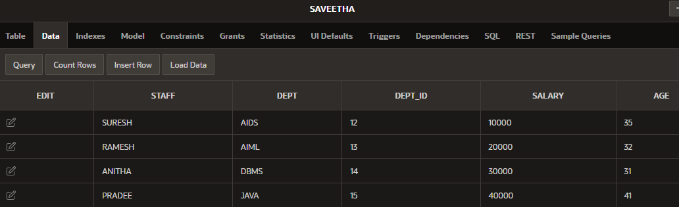

* **“MAX” GROUPING FUNCTION:**
* SELECT DEPT, MAX(SALARY)

FROM SAVEETHA

GROUP BY DEPT;

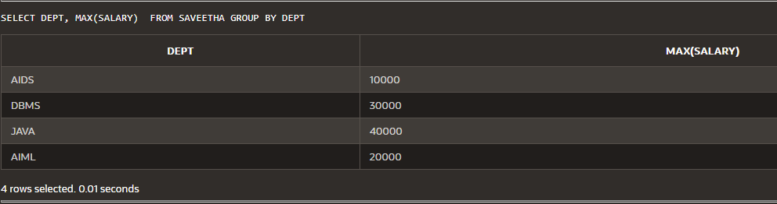

* **“MAX” GROUPING FUNCTION USING WHARE CONDITION:**
* SELECT DEPT, MAX(SALARY)

FROM SAVEETHA

WHERE SALARY>30000 GROUP BY DEPT;



* **AVG SALARY:**
* SELECT AVG(SALARY)

FROM SAVEETHA;



* **MIN SALARY:**

SELECT MIN(SALARY)

FROM SAVEETHA;

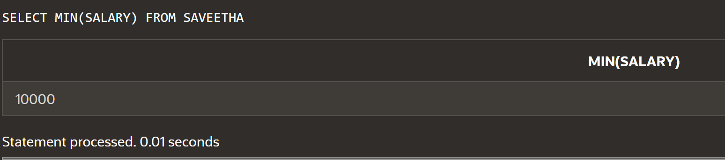

* **COUNT THE DEPARTMENT:**

SELECT COUNT(DEPT)

FROM SAVEETHA;

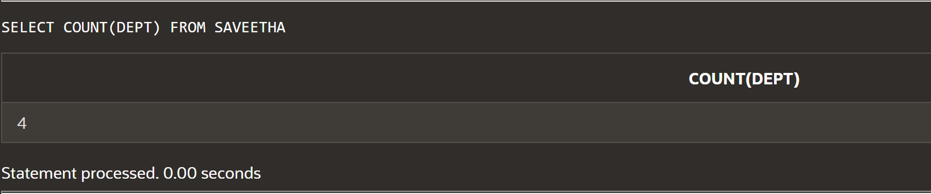

* **COUNT(*) :**

SELECT COUNT(*)

FROM SAVEETHA

WHERE (DEPT_ID > 12);

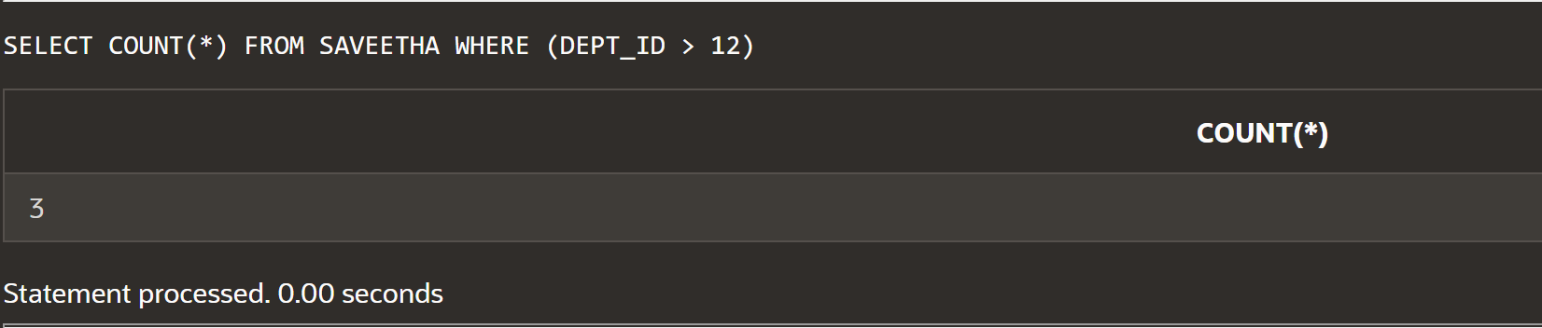

* **REMOVE THE DUPLICATE DATA USING “DISTINCT”:**

SELECT DISTINCT STAFF

FROM SAVEETHA;

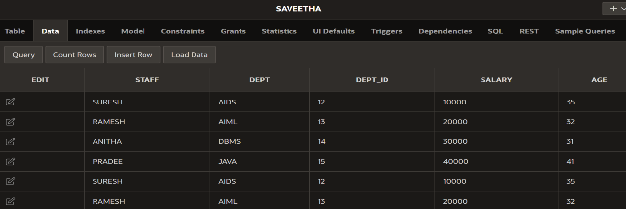

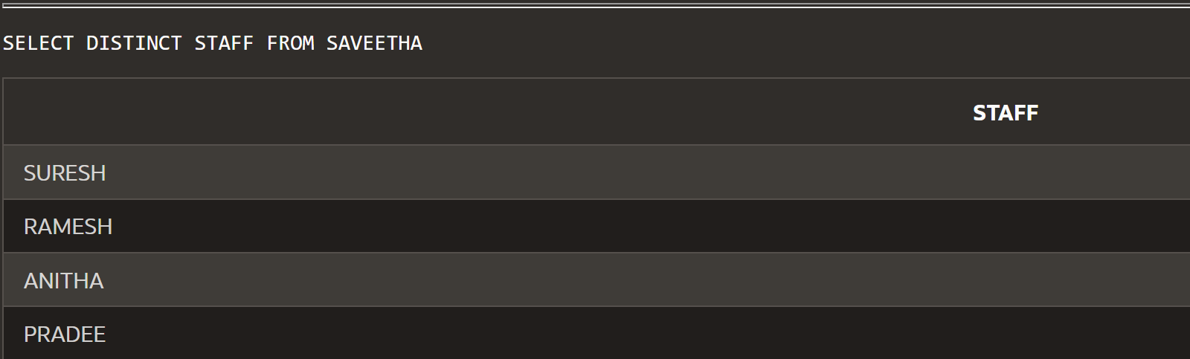

* **USING “COUNT AND DISTINCT”:**

SELECT COUNT (DISTINCT STAFF)

FROM SAVEETHA;

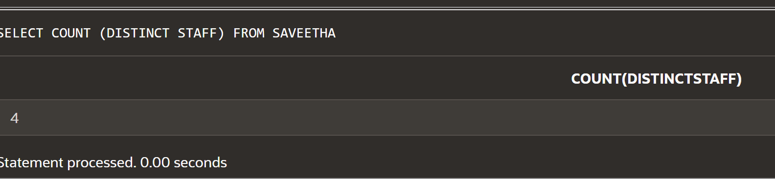

* **USING “NVL AND AVERAGE”:**

SELECT AVG(NVL(SALARY,0))

FROM SAVEETHA;

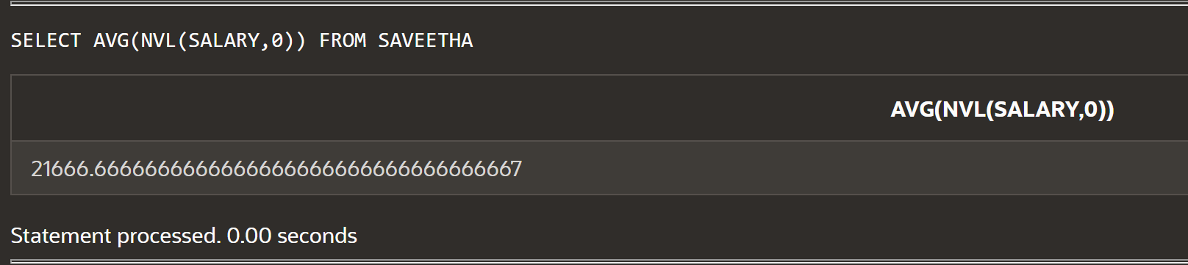

* **TO FIND THE AVERAGE MARKS USING WHERE CONDITION:**

SELECT AVG(MARKS) FROM STUDENT WHERE STUDENT_ID>=1;

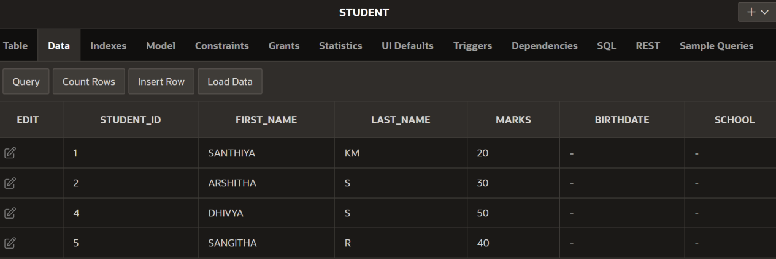

**OUTPUT:**

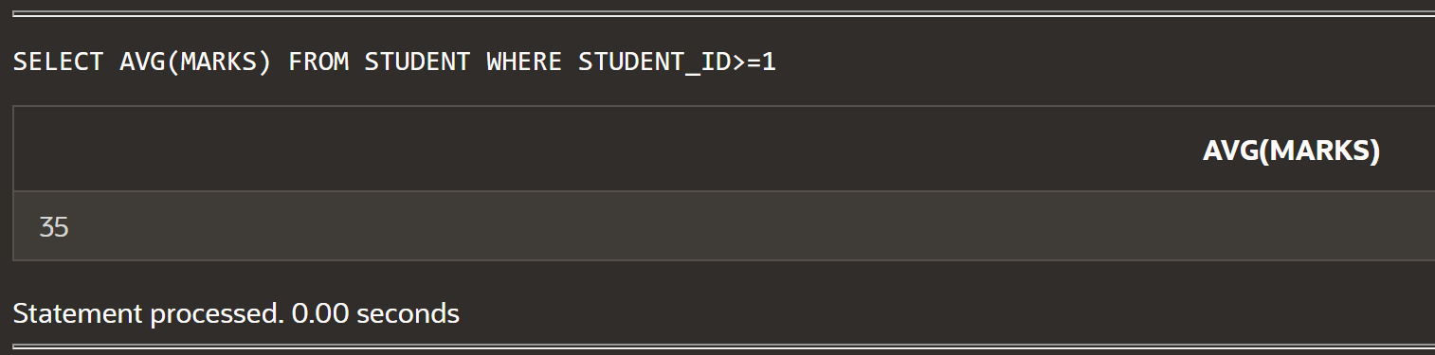

* **AVERAGE USING GROUP BY:**

SELECT DEPT_ID,AVG(SALARY)

FROM SAVEETHA

GROUP BY DEPT_ID

ORDER BY DEPT_ID;

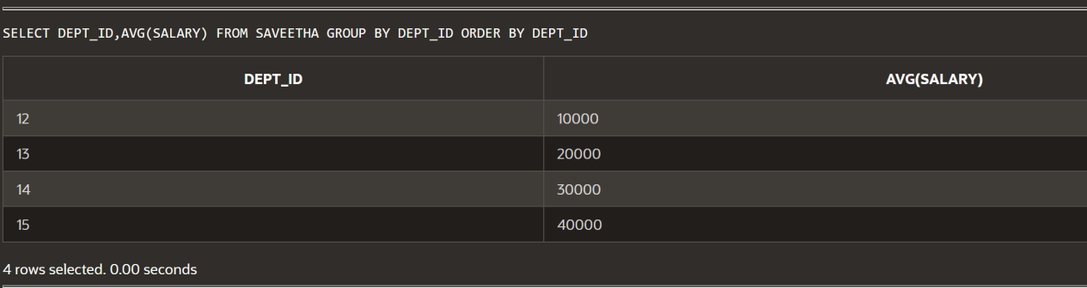

* **TO FIND THE MAXIMUM SALARY USING GROUP BY:**

SELECT MAX(SALARY)

FROM SAVEETHA

GROUP BY DEPT;

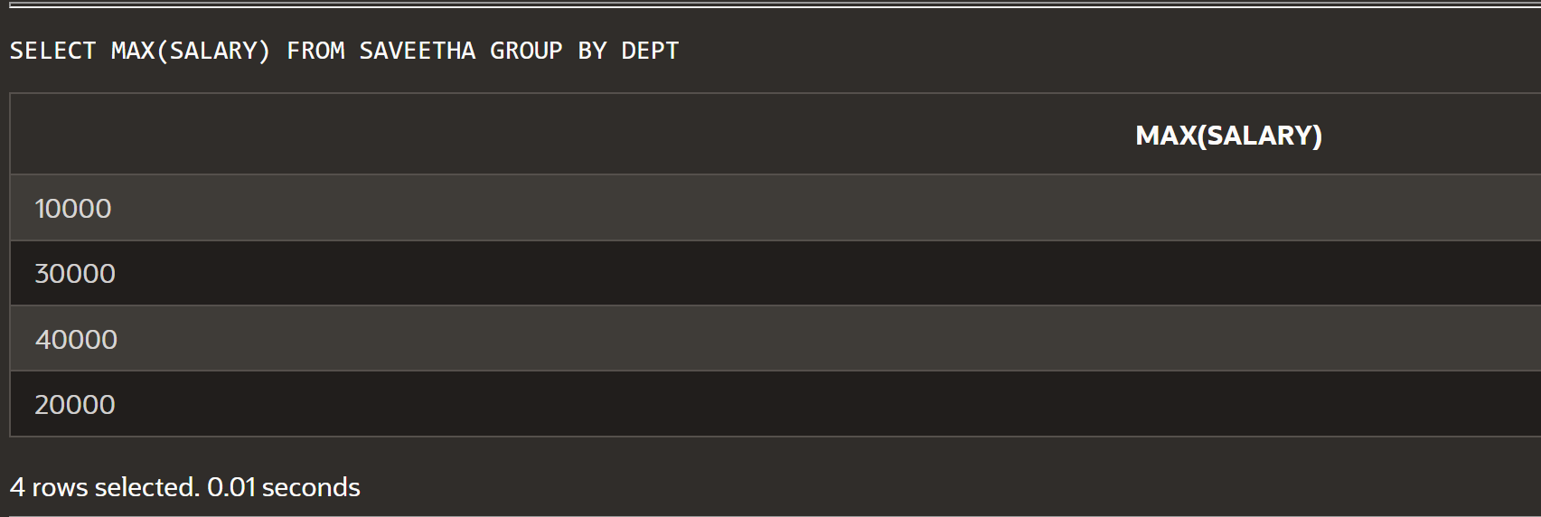

* **TO FIND THE MAXIMUM SALARY WITH “GROUP BY”:**

SELECT DEPT, MAX(SALARY)

FROM SAVEETHA

GROUP BY DEPT;

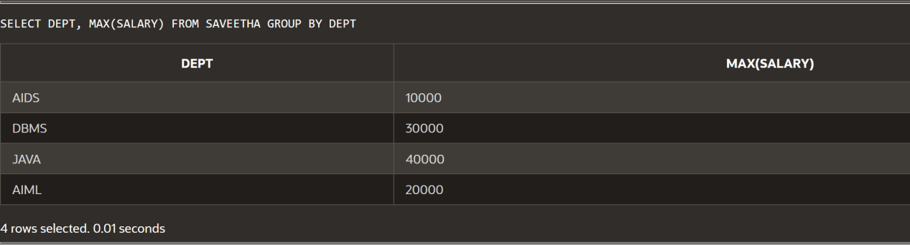

* **COUNT AND COMPARE THE FIELD:**

SELECT COUNT(STAFF),AGE

FROM SAVEETHA

GROUP BY AGE

ORDER BY AGE;

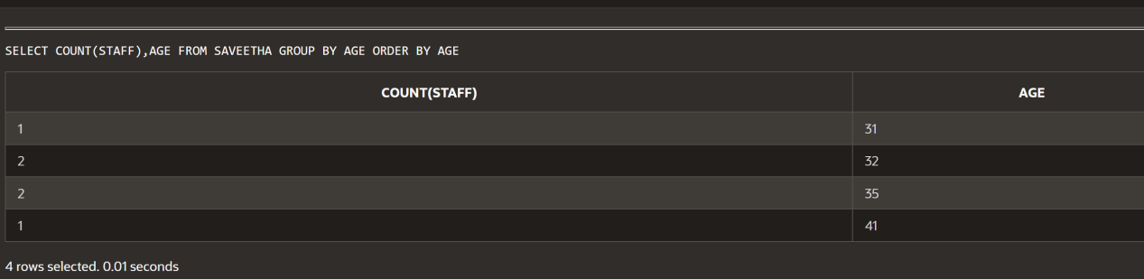

* **GROUP BY:**

SELECT STAFF, ROUND(AVG(SALARY)) AS STAFF_DETAIL

FROM SAVEETHA

GROUP BY STAFF

ORDER BY STAFF;

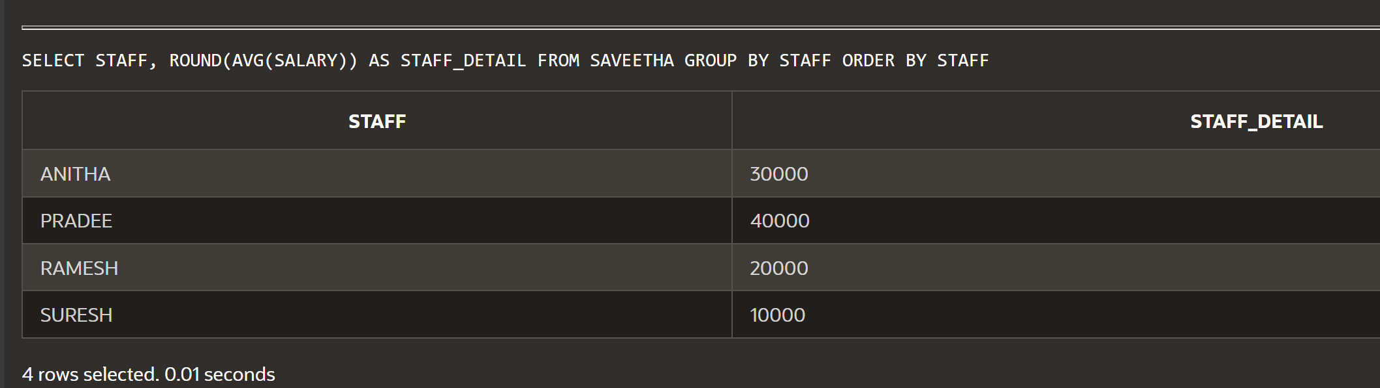

* **GROUP WITHIN A GROUP:**

SELECT DEPT_ID,SALARY,COUNT(*)

FROM SAVEETHA

WHERE DEPT_ID=12

GROUP BY DEPT_ID,SALARY;

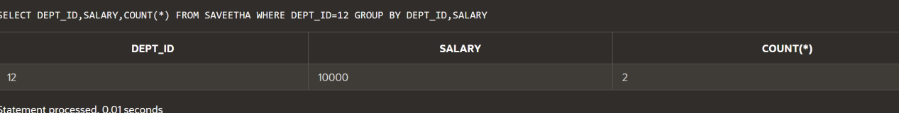

* **NESTING GROUP FUNCTION:**

SELECT MAX(AVG(SALARY))

FROM SAVEETHA

GROUP BY DEPT_ID;

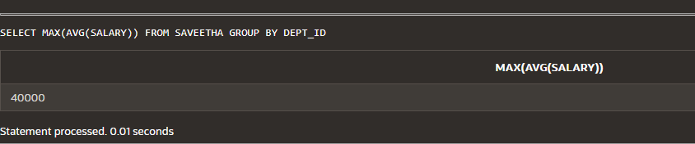

* **GROU FUNCTION USING HAVING:**

SELECT DEPT_ID,MAX(SALARY)

FROM SAVEETHA

GROUP BY DEPT_ID

HAVING COUNT(*)>1

ORDER BY DEPT_ID;

